Different User Roles

|  |  |  |
| --- | --- | --- |
| Document Prepared By: |  | Arkam Abu Bakar |
| Document Reviewed By: |  | Fatima Afzaal / Saad Mirza |

Table of Contents

Super User 3

Practice Admin 5

Provider (Vendor) 11

Provider (Non-Vendor) 13

Staff 15

# Super User

**Credentials:** [jim.brown@curemd.com](mailto:jim.brown@curemd.com) / CMDSupport.2K&@

* Go to the following URL <https://staging.novelhealth.ai/account>.
* Log into the NovelHealth application with valid Super Admin credentials. Take credentials from your TL/PM.
* On login, practice admin will land on the **dashboard**.

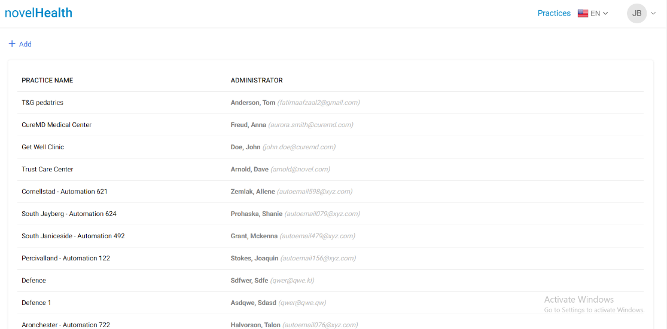

* On dashboard, **Practices** and their **Administrator** are present.

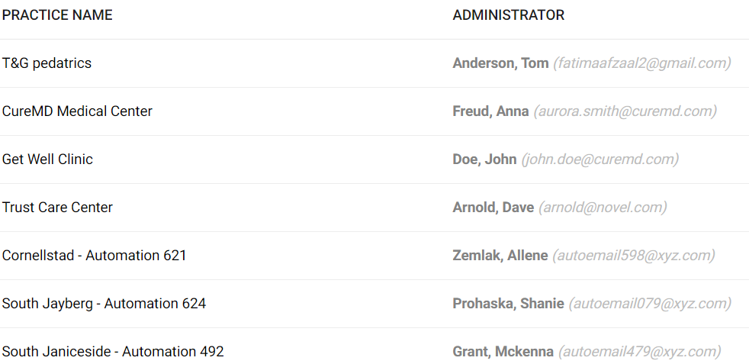

* On dashboard, “**Add”** button is present. Practice admin can add new practice by providing practice and administrator information.

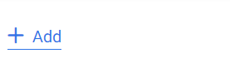

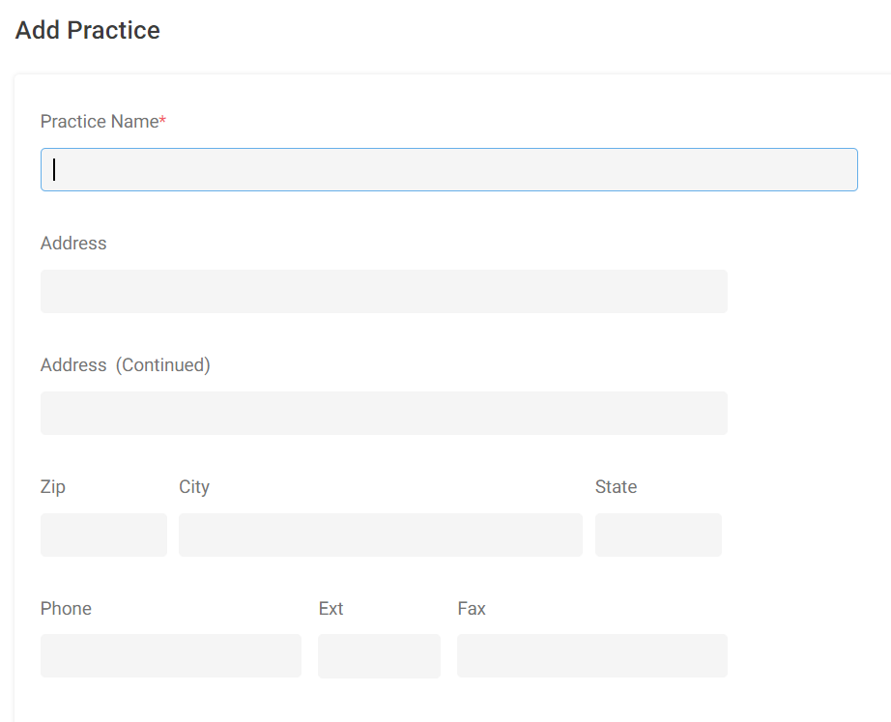

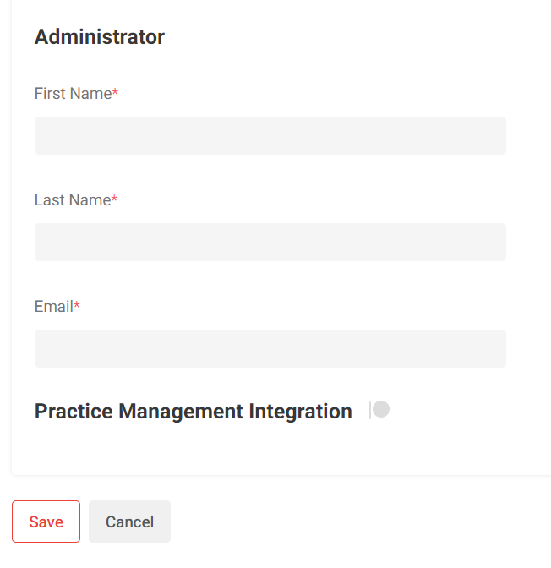

# Practice Admin

**Credentials:** james.watson@curemd.com / CMDSupport.2K&@ (For non-vendor practice admin. Non-vendor means the practices and subsequent users that do not belong to the CureMD application.)

**Credentials:** richard.green@curemd.com / CMDSupport.2K&@ (For vendor practice admin. Vendor means the practices and subsequent users that are a part of the CureMD application.)

* Go to the following URL <https://staging.novelhealth.ai/account>.
* Log into the NovelHealth application with valid Practice Admin credentials. Take credentials from your TL/PM.
* On login, practice admin will land on the **Users** page.

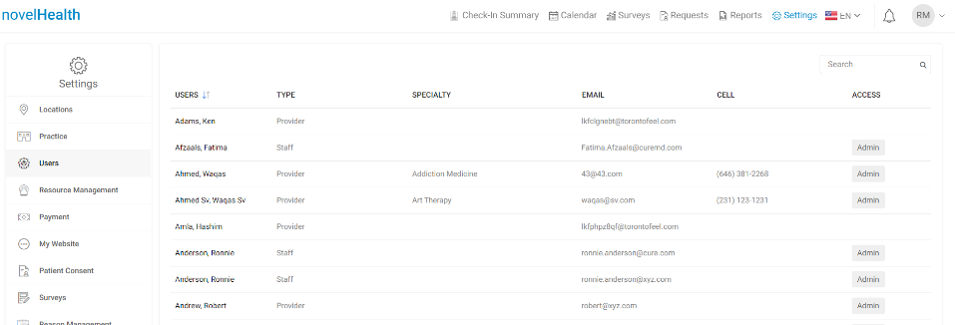

* Practice Admin can view:
  + **Check-In Summary** – In check-in summary page, the **DCI** **Appointments** booked for Resources/Providers are present.

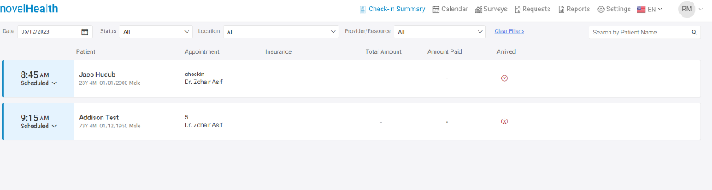

* + **Calendar** – In calendar module, the calendar of provider locations is present. Appointments booked for provider's virtual facility are also present in calendar module.

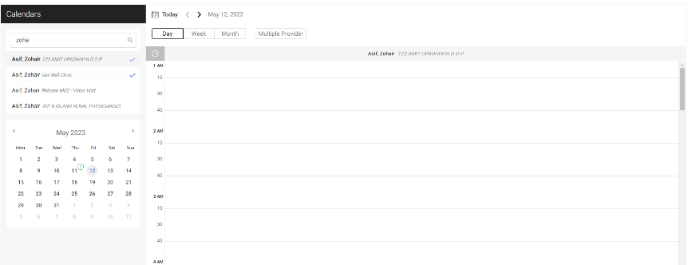

* + **Surveys –** In surveys, survey responses against survey forms attached with provider location are present.

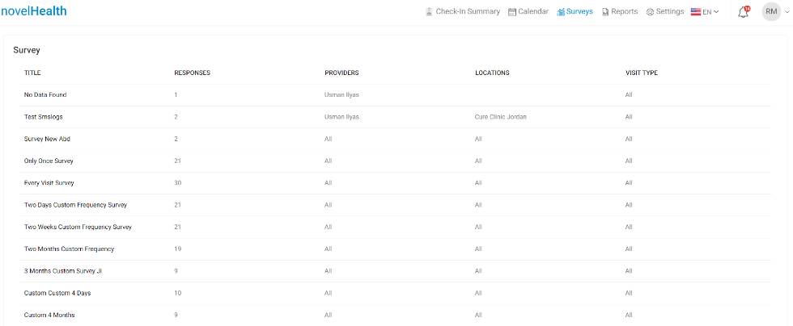

* + **Requests –** In requests page, the appointment requests from patients to providers are present for **Accept / Reject** feature.

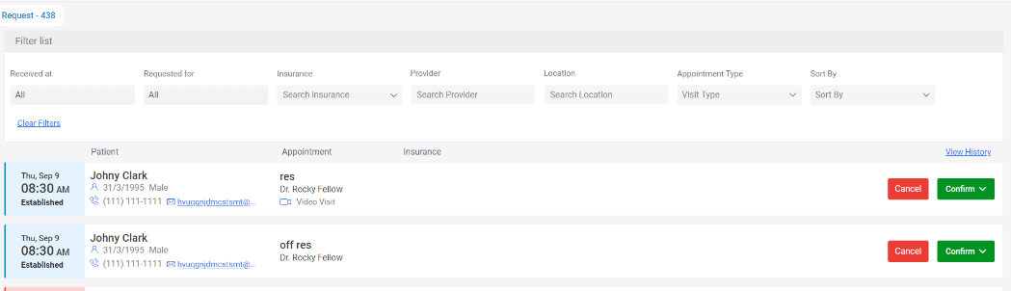

* + **Reports –** In reports, **Session** **Usage**, **Text Message Logs** and **Checked-In Appointment Report** are present.

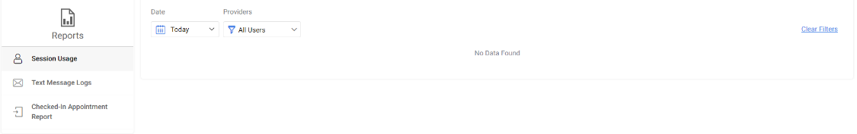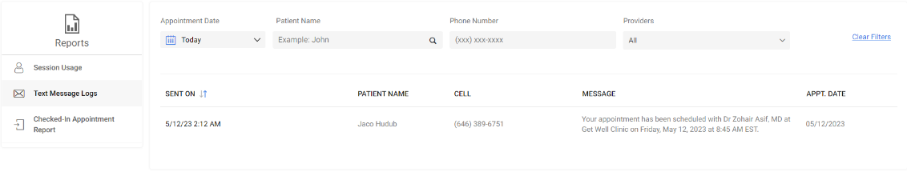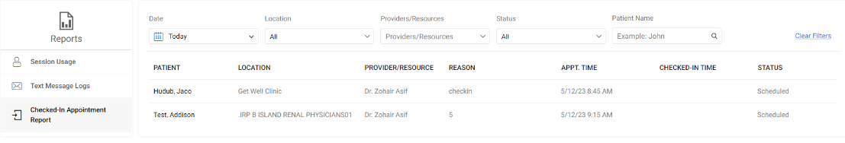

* + **Settings -** In the “Settings”, practice admin can view:
    - **Locations** – In locations, practice locations are present.

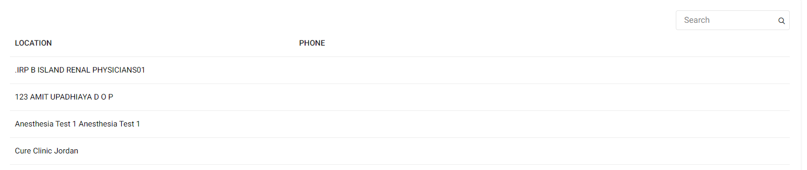

* + - **Practice** – In practice, general setting of the practice is present.

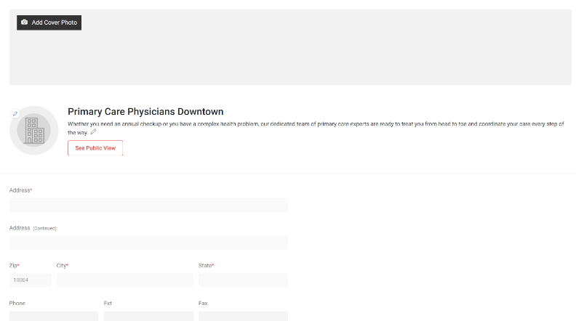

* + - **Users** – In users, **Provider** and **Staff** member associated with practice are present. Practice admin can also edit the access rights of Provider and Staff members.

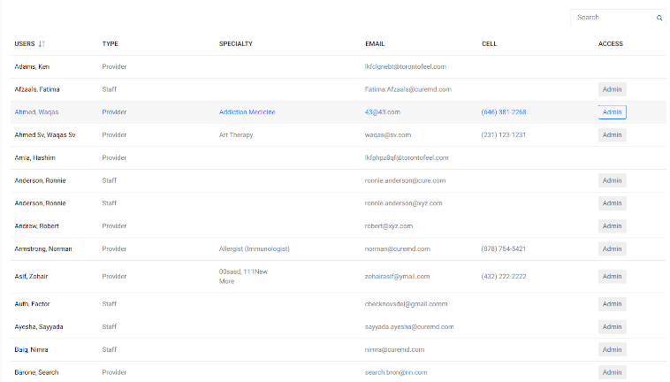

Workflow:

Settings>Users>Edit user>Provider>Account>**Practice Administrator**.

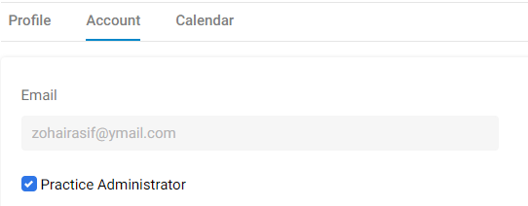

Settings>Users>Edit user>Staff>**Practice Administrator**.

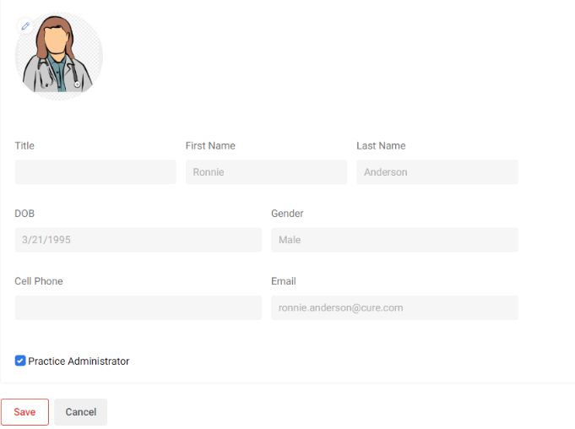

* + - **Resource** **Management** – In resource management, resources associated with practice are present. Resource are medical equipment /facility that can be used in providing healthcare services.

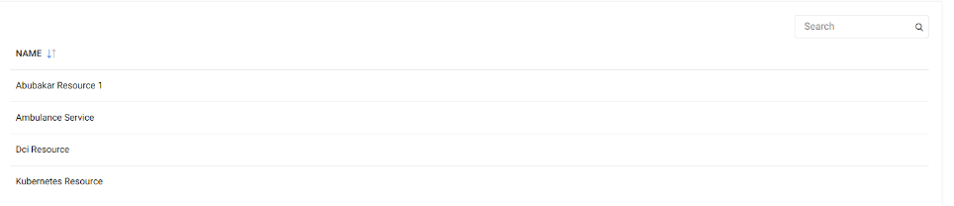

* + - **Payment** – In payment, online payment gateway likes **Stripe**, **Fortress**, **Global Pay** can be configured for the practice.

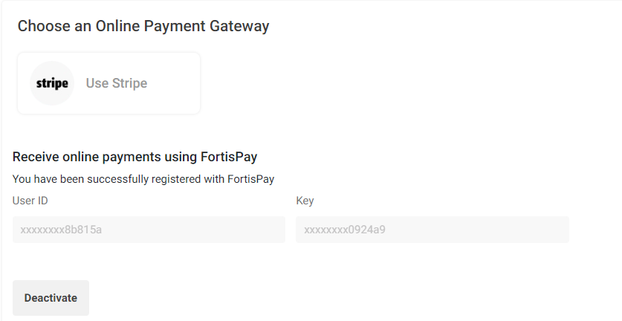

* + - **My** **Website** – In my website, Code / Link of the practice are present. Practice admin can copy and share the link of practice with patients.

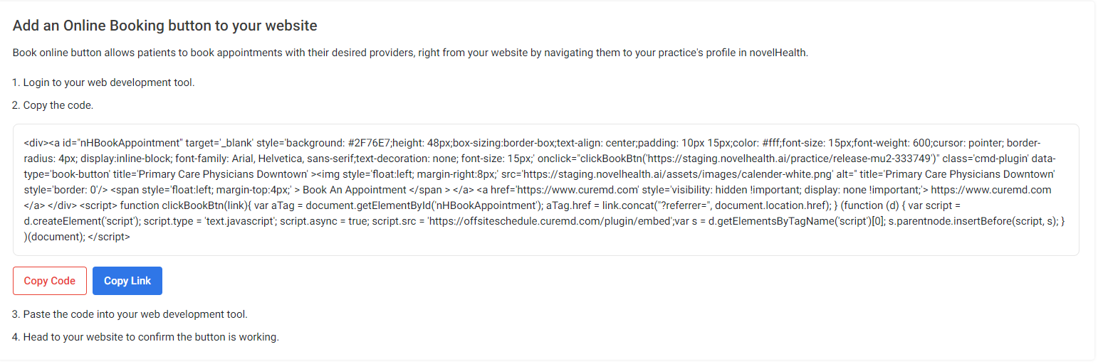

* + - **Patient Consent** – In patient consent, consent forms are present. Provider can ask willingness or approval of patient using consent forms. Patient can view the consents in appointment booking and in check-in flow.

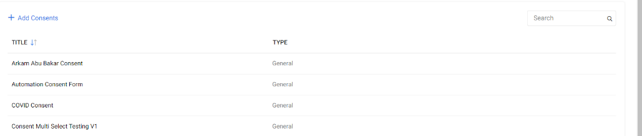

* + - **Surveys** – In surveys, practice admin can add surveys that can be triggered to the patients to collect response after the appointment.

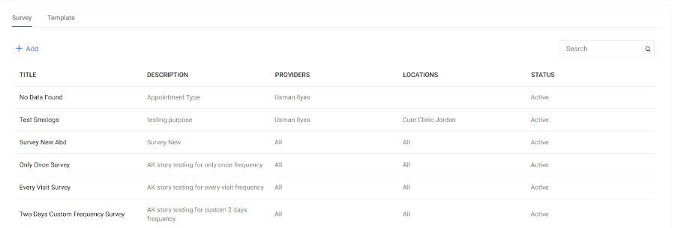

* + - **Reason** **Management** – In Reason Management, appointment reasons are present that can be associated with provider location calendar. Patient will select the appointment reason in appointment booking flow.

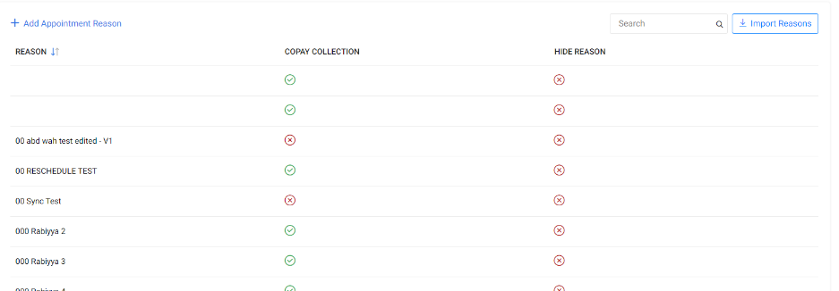

* + - **Change** **Password** – In change password, practice user can set the new password for the practice user account.

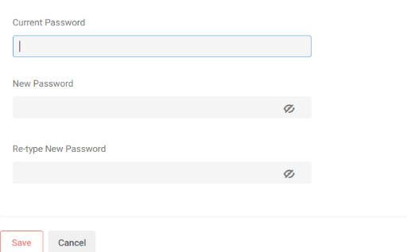

* + - **Custom** **Forms** – In custom forms, forms are present that can be associated with provider location calendar. The forms will appear in patient check-in flow to collect the response.

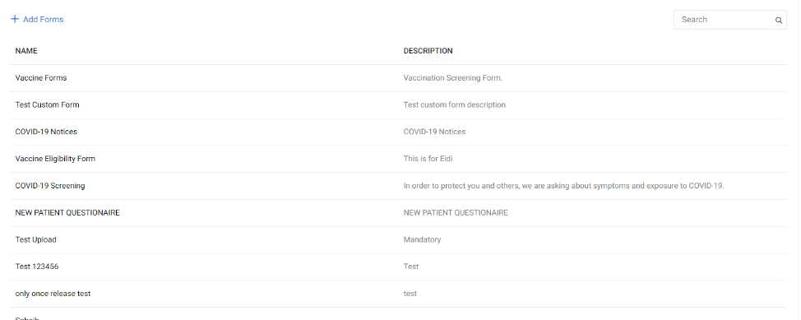

* + - **Reminders** – In reminders, practice user can set the reminders for patients for Office Visit / Tele Visit appointments. Practice user can also check the Reminder Email / Reminder Text template.

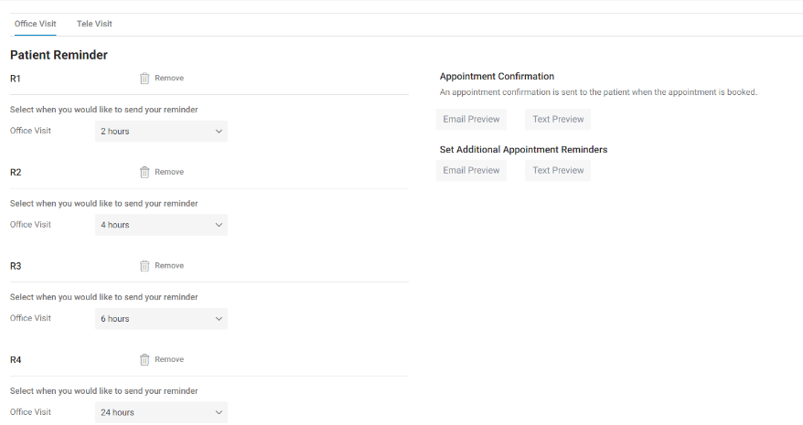

* + - **Reputation** **Management** – Reputation management tab appear for practice admin when email account is configured with **Birdeye**. The purpose of reputation management is enhancing the reputation of practice. In reputation management, practice user can configure the Birdeye reputation management third party application with the practice.

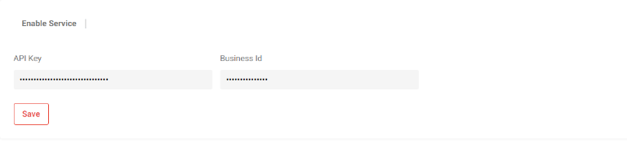

# Provider (Vendor)

* Go to the following URL <https://staging.novelhealth.ai/account>.
* Log into the NovelHealth application with valid Provider (Vendor) credentials. Take credentials from your TL/PM.
* On login, you will land on the provider dashboard.
* Provider can view:
  + **Dashboard**– In dashboard, appointments are present that are scheduled for today with the provider.

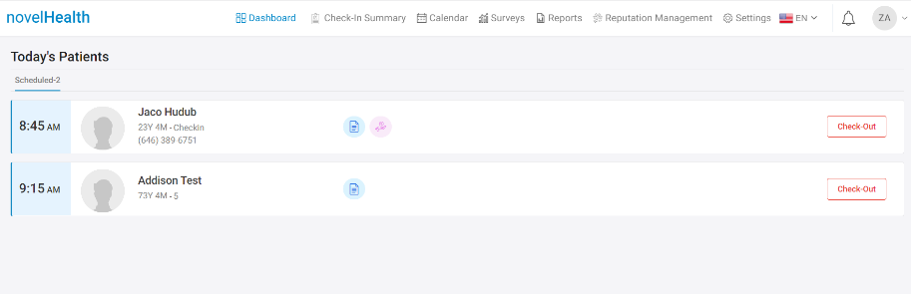

* + **Check-In Summary** – In check-in summary page, the **DCI** **Appointments** booked for Resources/Providers are present.

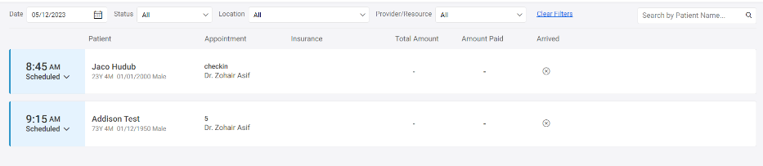

* + **Calendar** – In calendar module, the calendar of provider locations is present. Appointments booked for provider's virtual facility are also present in calendar module.



* + **Requests –** In requests page, the appointment requests from patients to providers are present for **Accept / Reject** feature.



* **Reputation** **Management** – Reputation management tab appear for provider when provider email account is configured with **Birdeye**. In reputation management, provider can configure the Birdeye reputation management third party application.
  + **Settings -** In the “Settings”, provider can view:
    - **My Profile** – In my profile, general setting of the provider is present.
    - 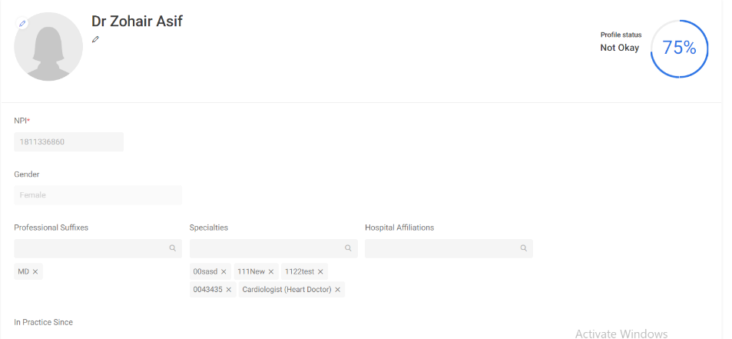
    - **Televisit Service** – In Televisit service, provider can manage the settings for TM appointments.

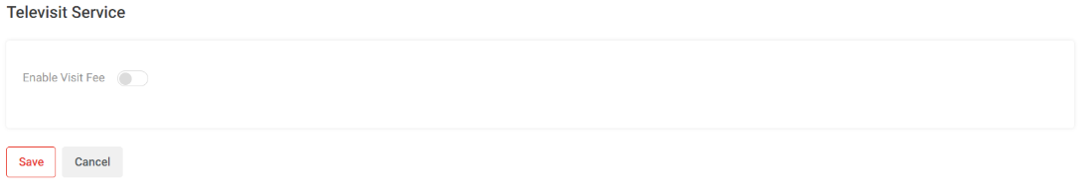

* + - **Change** **Password** – In change password, provider can set the new password for the provider account.



# Provider (Non-Vendor)

* Go to the following URL <https://staging.novelhealth.ai/account>.
* Log into the NovelHealth application with valid Provider (Non-Vendor) credentials. Take credentials from your TL/PM.
* On login, you will land on the provider dashboard.
* Provider can view:
  + **Dashboard**– In dashboard, appointments are present that are scheduled for today with the provider.

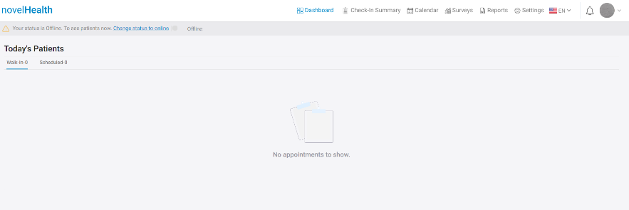

* + **Check-In Summary** – In check-in summary page, the **DCI** **Appointments** booked for Resources/Providers are present.



* + **Calendar** – In calendar module, the calendar of provider locations is present. Appointments booked for provider's virtual facility are also present in calendar module. **The non-vendor provider can book the appointment for the patients from calendar module.**



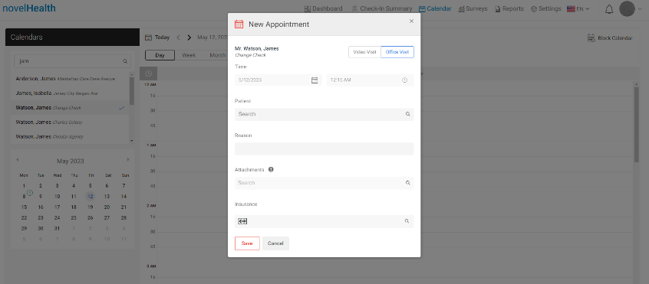

* **Requests –** In requests page, the appointment requests from patients to providers are present for **Accept / Reject** feature.



* **Reputation** **Management** – Reputation management tab appear for provider when provider email account is configured with **Birdeye**. In reputation management, provider can configure the Birdeye reputation management third party application.
* **Settings -** In the “Settings”, provider can view:
  + - **My Profile** – In my profile, general setting of the provider is present.
    - 
    - **Televisit Service** – In Televisit service, provider can manage the settings for TM appointments.



* + - **Change** **Password** – In change password, provider can set the new password for the provider account.



# Staff

* Go to the following URL <https://staging.novelhealth.ai/account>.
* Log into the NovelHealth application with valid staff credentials. Take credentials from your TL/PM.
* On login, you will land on the staff’s dashboard.
* Staff can view:
  + **My Meeting Invites** – In my meeting invites, staff can check all the scheduled TM appointments for today associated with the providers**.** No office visit appointments appear on staff dashboard. **Staff member can be linked to more than one provider.** So, in my meeting invites, staff can check the scheduled appointment for today associated with all the providers.

